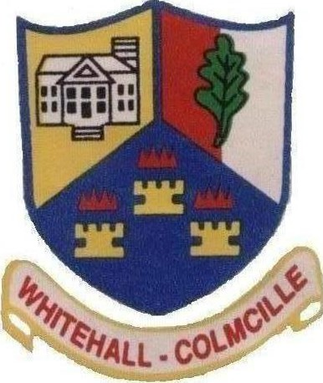
Players’ Code of Conduct

As a member of Whitehall Colmcille GAA Club, I will follow the following Code of Conduct:
- Abide by all club rules
- Treat others on the team in a respectful manner
- Respect opponents, they are not the enemy. They are partners in a sporting event
- Shake hands after the match, whoever wins
- Respect team members and support them both when they do well and when things go wrong
- Be modest in victory and gracious in defeat – “Be A Sport”
- Respect our club and other club’s property and clubhouse
- Be punctual for training and matches
- Let the mentors know if you will be absent from training or matches
- Be attentive to coaches during training sessions and matches
- Never to use abusive language, or argue with, the referee, officials, team mates, mentors or opponents
- Never to fight, bully or use violent or dangerous behaviour
- Never to behave in a manner that may bring the name of Whitehall Colmcille GAA Club into disrepute

Note: Parents, please read through this sheet with your son/daughter. Ensure that they understand the elements involved before signing the “Code of Conduct”
Signed ....................................................................................................(Player’s signature)

Signed.....................................................................................................(Parent’s signature)
www.whitehallcolmcille.ie

